# Virtual Laboratory: General Instructions

For this virtual laboratory session you are expected to complete a laboratory report (this worksheet) in full – this will includes writing a summary of the procedure, drawing a picture of the experimental equipment used, recording the results and observations (seen in the video) and then answering the STAWA “Processing of results and questions” section.

There are two ways you can do this:

1. download this word document, type in all the relevant information and use shapes or drawing to do the pictures (for mathematical equations and calculation use Equation or Ink Equation). Then save the file as a PDF (for macs it is just save as – pdf; for windows pc it is print – print to pdf). Save the file with title: {YOURNAME}_Expt16_{DATE} e.g. Bloggs_Expt17_19042020. Then upload the file to SEQTA folios
2. Print the worksheet out, hand write in required information. Scan the document and save it as a PDF. Save the file with title {YOURNAME}_Expt16_{DATE} e.g. Bloggs_Expt17_19042020. Then upload the file to SEQTA folios

Key points:

* Must be a PDF file (no other file format will be checked or acknowledge, and I will not chase you if you submit the wrong file type. PDF documents only please).
* Must be submitted via SEQTA using folios (set up a folio called Chem 11).
* We will be going through the experiment in a webex session or in class (if a lot of students are in class, webex sessions will be cancelled and students at home will be given the fully worked answers after they have submitted the file).

You should complete most, if not all, of the worksheet during the scheduled Experiment Time. You are not required to do the practical side (or the cleaning up) so an hour should be more than enough time to complete the task. Please keep in mind the types of questions you were asked on your Period Zero Lab validation test.

# Experiment 17: Water of crystallisation of barium chloride

Reference: STAWA book pages 46 (you will need to use your textbook to guide you through this worksheet)

## Procedure:

1. Write a summary of the experimental procedure from the book (does not need to be word for word just a summary).

|  |
| --- |
|  |
|  |
|  |
|  |
|  |
|  |
|  |
|  |

1. What safety considerations are there in this experiment and how would you minimize the risk to you and the equipment.

|  |
| --- |
|  |
|  |
|  |
|  |
|  |
|  |
|  |
|  |

1. Draw a picture of the experimental set up for this experiment (from the book or wait to watch the video the video then draw the picture).

## Results and Observations:

Watch the following video and complete the two tables on the next page:

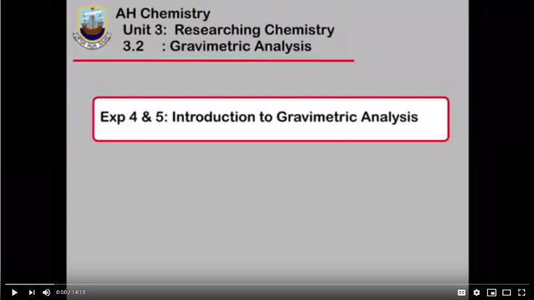<https://www.youtube.com/watch?v=mOcZK-N_dwM>

Observations: the observations are not shown in the video, mostly as they are not particularly noticeable. You start with a clumpy white solid and you finish with a white powder. You may observe the water vapour coming from the crucible at the beginning of the heating process. The main observation for this experiment is the change in mass due to the loss of water from the solid.

1. Results:

|  |  |
| --- | --- |
| **Materials** | **Mass (g)** |
| Crucible & lid |  |
| Crucible, lid & hydrated barium chloride |  |
| Hydrated barium chloride (calculate) |  |
| Crucible, lid & barium chloride |  |
| Barium chloride (calculate) |  |

## Processing of results and questions (slightly modified to the questions in the textbook)

1. Using the mass of the anhydrous barium chloride (the solid after heating) calculate the number of moles of BaCl2 present.
2. Calculate the mass of water in the original solid and use this to calculate the number of moles of water present in the hydrated barium chloride.
3. Calculate the ratio n(BaCl2):n(H2O). What is the empirical formula of the compound? [BaCl2.xH2O find the value for x]
4. What is the percentage composition of barium in both the anhydrous BaCl2 and the hydrated barium chloride (use the empirical formula you calculated in Q3)?

## Post-lab questions:

As the video talked you through the calculations here are two questions for you to figure out on your own:

1. A 15.67 g sample of a hydrate of magnesium carbonate was heated, without decomposing the carbonate, to drive off the water. The mass was reduced to 7.58 g. What is the formula of the hydrate?
2. A 3.216 g sample of NaxByOz.XH2O was heated to drive off the water of hydration. The resulting anhydrous salt, which has a mass of 2.222 g, contained 0.5077 g of sodium, 0.4775 g of boron, and some oxygen. What is the formula of the hydrated salt? [find the values of x, y, z and X]